**6. Use Case Diagram**

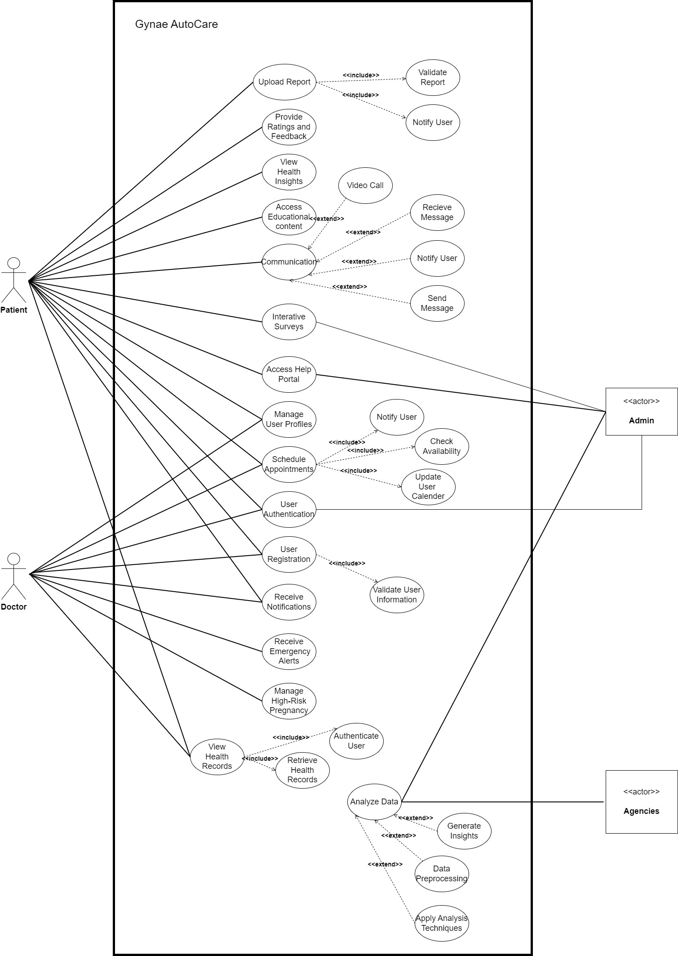

***Figure 1: Use Case Diagram***

This diagram illustrates the relationships between different use cases in the Gynae-Autocare system. It identifies actors (such as Admin, Doctor, and Patient) and their interactions with various use cases. This figure content references Figure 1.

**7. Activity Diagram**

**7.1 Admin Activity Diagram**

The Admin Activity Diagram showcases the step-by-step flow of activities performed by the system administrator in managing the Gynae-Autocare system. This could include tasks like user management, system configuration, and data analysis. This figure content references Figure 2.

***Figure 2: Admin Activty Diagram***

**7.2 Doctor Activity Diagram**

The Doctor Activity Diagram provides a visual representation of the sequential activities performed by a doctor within the Gynae-Autocare system. This may include tasks like reviewing patient records, scheduling appointments, and managing high-risk pregnancies. This figure content references Figure 3.

***Figure 3 : Doctor Activity Diagram***

**7.3 Patient Activity Diagram**

***Figure 4 : Patient Activity Diagram***

**9. ERD Diagram**

The Entity Relationship Diagram (ERD) represents the relationships between different entities in the Gynae-Autocare database. It typically includes entities such as users, appointments, health records, etc. This figure content references Figure 19.

***Figure 19 : Entity Relationship Diagram***